Road Map to Web Development

* Front End Web Dev

# Internet

**Phase - I**

How does the internet work?

What is HTTP?

Browser and how they work?

**Phase – II**

DNS and how it works?

What is Domain Name?

What is hosting?

**How does the Internet work?**

**Summary:** The Internet is the backbone of the Web, the technical infrastructure that makes the web possible. At its most basic, the Internet is a large network of computers which communicate all together.

**Advance and In-detailed Network:** When two computers need to communicate, you have to link them, either physically (usually with an **Ethernet** cable) or wirelessly (for example with **Wi-Fi** or **Bluetooth** systems). All modern computers can sustain any of those connections.

Ethernet Cable Wi-Fi

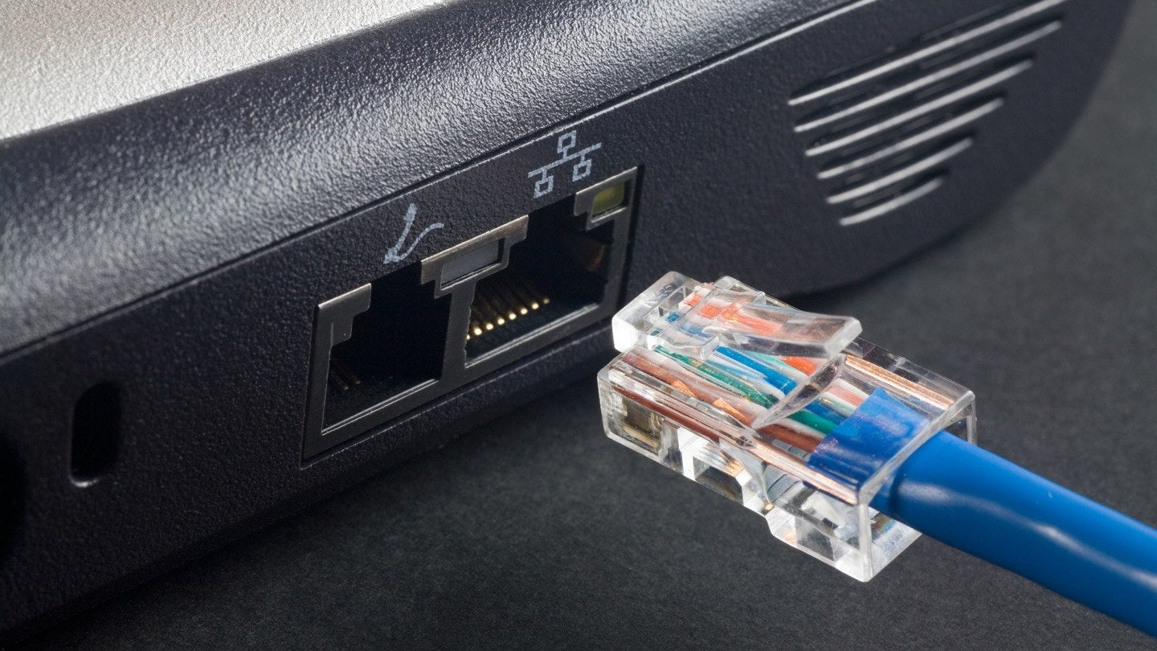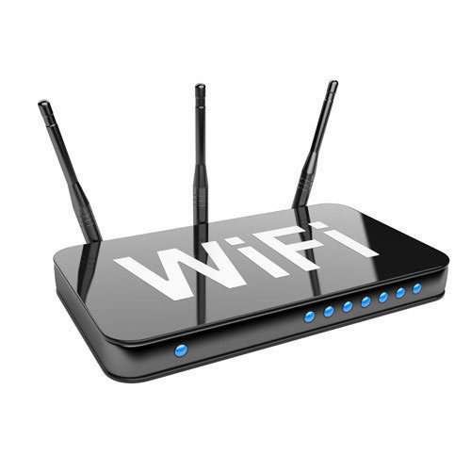

**Note:** For the rest of this document, we will discuss only about physical cables, but wireless networks work the same.

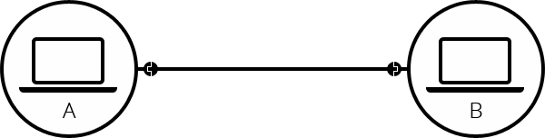

Such a network is not limited to two computers. You can connect as many computers as you wish. But it gets complicated quickly. If you’re trying to connect, say, ten computers, you need 45 cables, with nine plugs per computer.

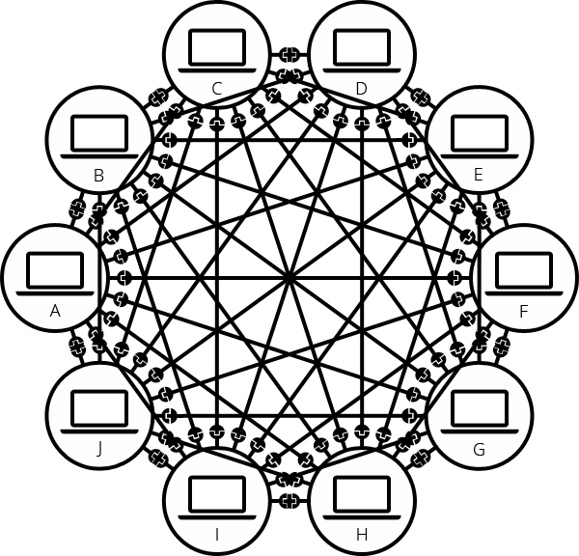

To solve this problem, each computer on a network is connected to a special tiny computer called a router. This router has only one job like a signaler at a railway station, it makes sure that a message sent from a given computer arrives at the right destination computer. To send a message to computer B, computer A must send the message to the router, which in turn forwards the message to computer B and makes sure the message is not delivered to computer C.

Once we add a router to the system, our network of 10 computers only requires 10 cables a single plug for each computer and a router with 10 plugs.

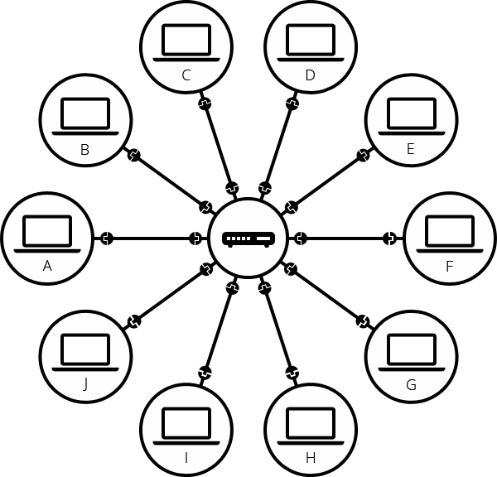

A network of networks

So far so good. But what about connecting hundreds, thousands, billions of computers? Of course a single router can’t scale that far, but, if you need carefully, we said that a router is a computer like any other, so what keeps us from connecting two routers together? Nothing, so let’s do that.

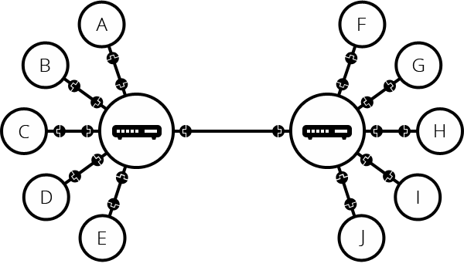

By connecting computers to routers, then routers to routers, we are able to scale infinitely.

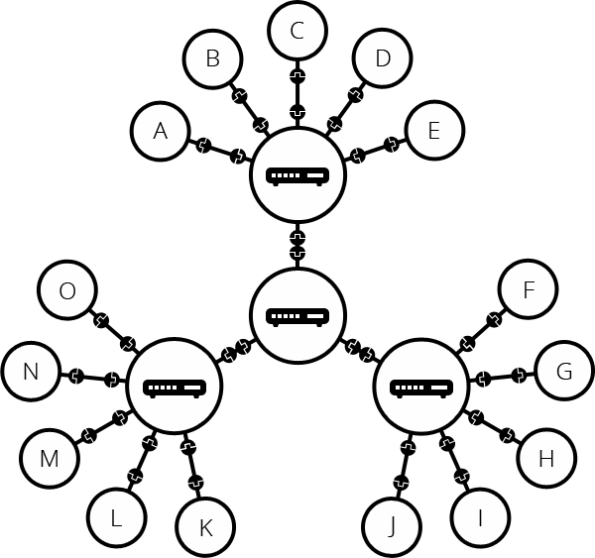

Such a network comes very close to what we call the Internet, but we’re missing something. We built that network for our own purposes. There are other networks out there: your friends, your neighbors, anyone can have their own network of computers. But it’s not really possible to set cables up between your house and the rest of the world, so how can you handle this? Well, there are already cables linked to your house, for example, electric power and telephone. The telephone infrastructure already connects your house with anyone in the world so it is perfect wire we need. To connect our network to the telephone infrastructure, we need a special piece of equipment called a modem. This modem turns the information from our network into information manageable by the telephone infrastructure and vice versa.

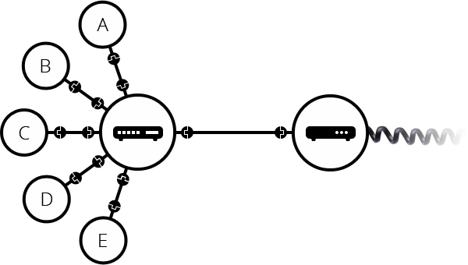

So we are connected to the telephone infrastructure. The next step is to send the messages from our network to the network we want to reach. To do that, we will connect our network to an Internet Service Provider (ISP). An ISP is a company that manages some special routers that are all linked together and can also access other ISPs’ routers. So that message from our network is carried through the network of ISP networks to the destination network. The Internet consists of this whole infrastructure of network.

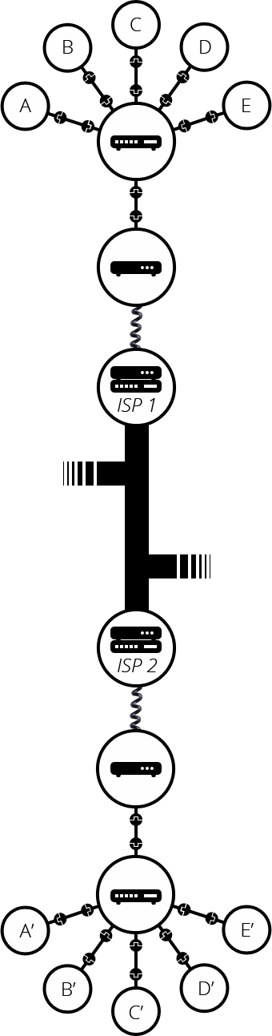

**Finding Computers**

If you want to send a message to a computer, you need to specify which one. Thus any computer linked to a network has a unique address that identifies it, called an “IP address” (Where IP stands for Internet Protocol). It’s an address made of a series of four numbers separated by dots, for example 192.168.2.10.

That’s perfectly fine for computers, but we human beings have a hard time remembering that sort of address. To make things easier, we can alias an IP address with a human readable name called a domain name. For example (at the time of writing, IP address can change) google.com is the domain name used on top of the IP address 173.194.121.32. So using the domain name is the easiest way for us to reach a computer over the internet.

